Design Document Report

**Network Application Development Project**

**A Simple File Transfer Service**

By

Alexandre Vallières #40157223

Samson Kaller #40136815

Course

COEN366: Communication Networks and Protocols

Presented to

Professor Chadi Assi

December 12th, 2022

Concordia University

# INTRODUCTION

This report contains the design documentation for the server and client python applications developed for the project. These python scripts implement a simple file transfer service according to the protocol specifications in the Project Description. This report will first cover flowcharts that describe the algorithms behind each program, client and server, followed by descriptions of the functions used in each script.

# FLOWCHARTS

This section contains flowcharts describing the algorithms for the Server and Client python scripts. First the Server will be covered followed by the Client. PlantUML was used to model and generate the flowcharts.

## Server Algorithm

The server algorithm is very straightforward. In short: it listens for client connections, waits to receive a client request, then handles the request and sends a response back to the client. Functions have also been created to handle these responses which can be found further on in section 3.0 FUNCTIONS.

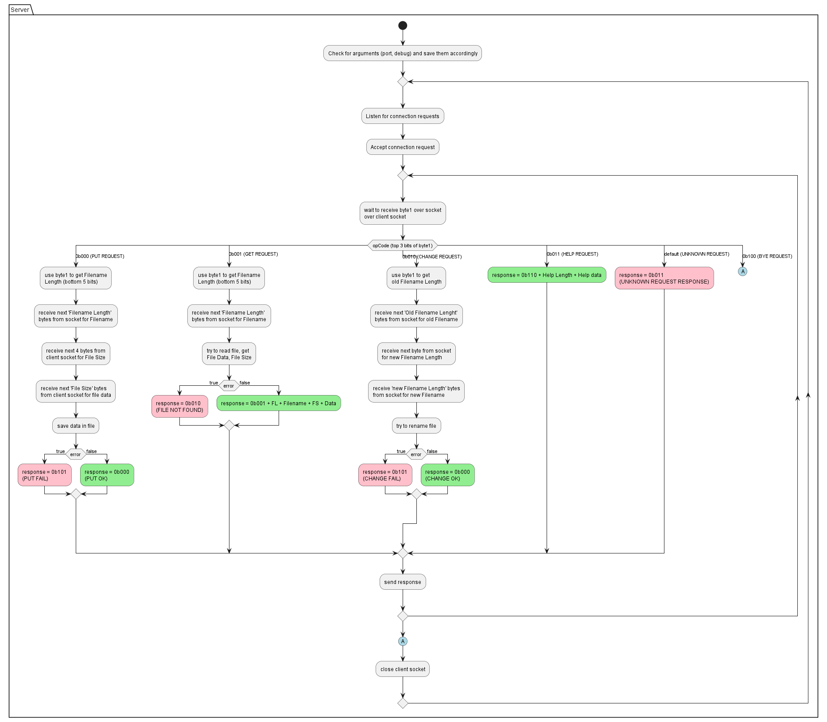

## Client Algorithm

The client algorithm is a little more complex. It connects to the server then waits for user to input commands. Then it sends the commands to the server and waits for a response. After receiving the response, it handles it appropriately. Functions have also been created to handle these requests and responses which can be found further on in section 3.0 FUNCTIONS.

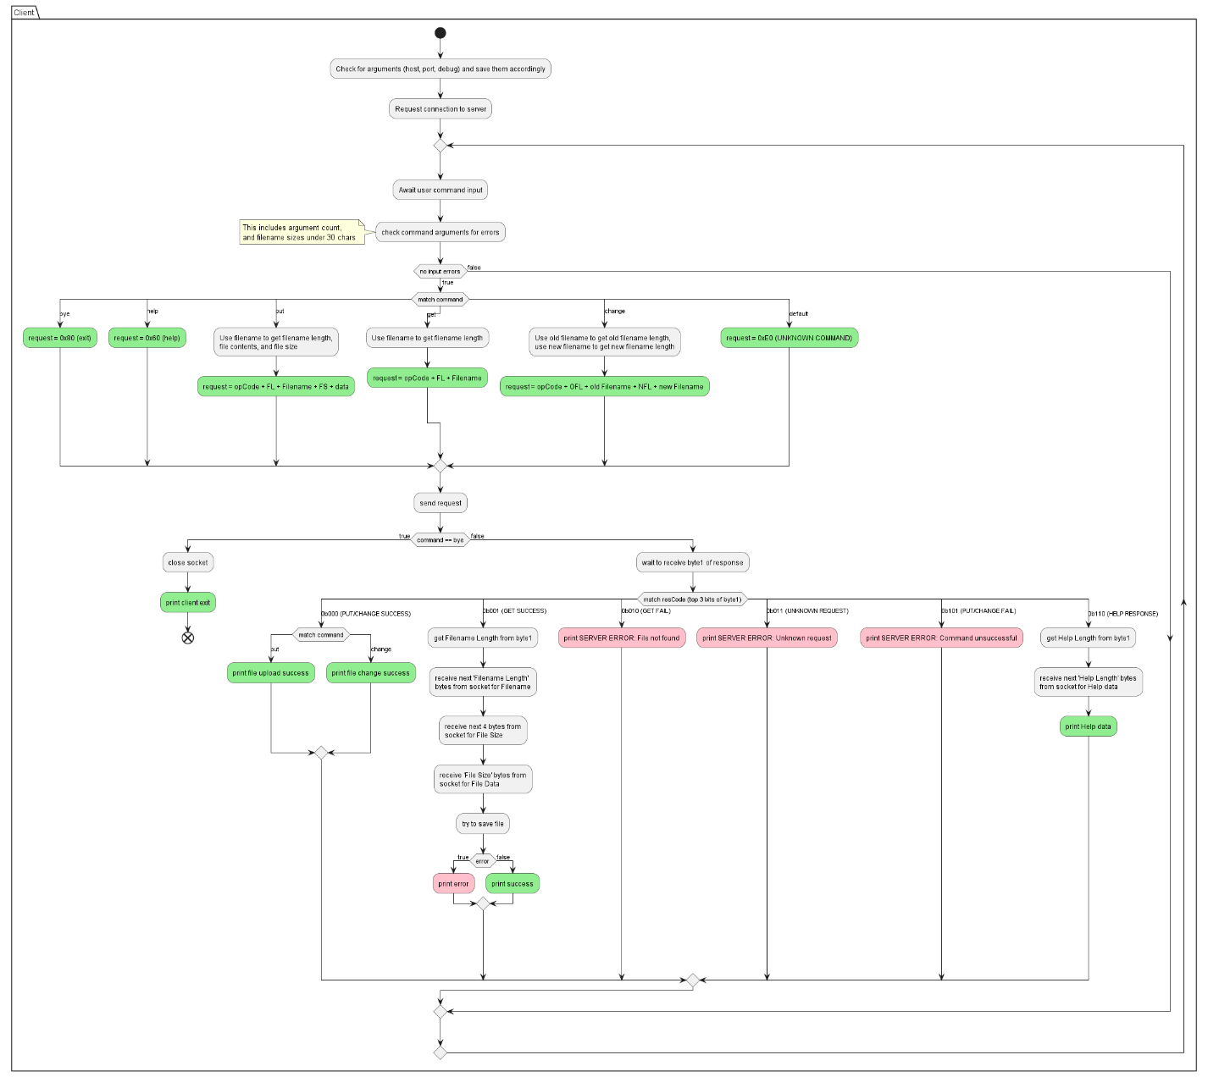

# FUNCTIONS

This section contains descriptions of the functions developed for the server and client applications. First the server functions will be covered followed by the client functions. These descriptions are pretty much the function definitions from the application python scripts, but they have been included here for documentation purposes.

## Server Functions

## Client Functions

